Project: SkillSphere – AI-Driven Career Readiness and Personalized Learning Recommendation Platform
GIT & DOCKER / CI-CD TECHNICAL ASSIGNMENT
Submitted in the partial fulfilment for the Course of
CSA1012 – SOFTWARE ENGINEERING
to the award of the degree of
BACHELOR OF TECHNOLOGY
IN
COMPUTER SCIENCE(AI)
Submitted by
R.Jalaja (192525365)
Under the Supervision of
DR ANITADAVAMANI K
SIMATS ENGINEERING
Saveetha Institute of Medical and Technical Sciences
Chennai-602105
Aug -2026

1. Problem Overview
SkillSphere is an AI-driven career readiness platform designed to help students understand their skills, identify skill gaps, and view career or learning recommendations. The project contains a frontend web interface and a backend REST API, with Docker used to package the application components.

Project Objectives
- Provide a simple student-facing interface for career-readiness activities.
- Organize the application into separate frontend and backend components.
- Use Git and GitHub to maintain source-code history and support collaborative development.
- Automate builds, tests and quality checks through a CI/CD workflow.
- Use Docker and Docker Compose for repeatable application deployment.

Key Functionalities
- Student profile access.
- Skill-gap identification.
- Career and learning recommendations.
- Backend REST API service.
- Containerized frontend and backend services.

Expected Outcome
The expected outcome is a maintainable application that can be developed on a Git branch, automatically validated by GitHub Actions, reviewed through a pull request, and deployed consistently using Docker.

2. CI/CD Requirements Analysis
For SkillSphere, the CI/CD pipeline should detect changes, install dependencies, perform automated validation, check dependency security, build Docker images, and provide feedback before changes are merged into the main branch.
Requirement | Type | Validation | Pipeline Stage
Frontend should load correctly | Functional | Browser validation | Deployment
Backend service should start | Functional | Container/service check | Build/Deployment
Automated tests should execute | Functional/Quality | npm test | Test
High-severity dependency issues should be detected | Security | npm audit | Security
Docker images should build successfully | Deployment | docker compose build | Package/Build
Pipeline should run on code integration | Process | GitHub Actions | CI Trigger

Non-Functional Requirements
- Reliability – every change should pass automated checks before integration.
- Maintainability – workflow files and project structure should be easy to understand.
- Portability – Docker should provide a consistent runtime environment.
- Security – dependency auditing should be part of the pipeline.
- Usability – deployment should result in an accessible SkillSphere web interface.

3. CI/CD Pipeline Architecture
The SkillSphere CI/CD pipeline is designed as a clear sequence that is easy to explain and reproduce. A developer makes changes in the project and pushes them to GitHub. The develop branch is validated by GitHub Actions, where the source is checked out, Node.js is prepared, dependencies are installed, automated tests are executed, security is checked and Docker images are built. After successful validation, a pull request is used to integrate develop into main. Docker Compose is then used to run the frontend and backend services.
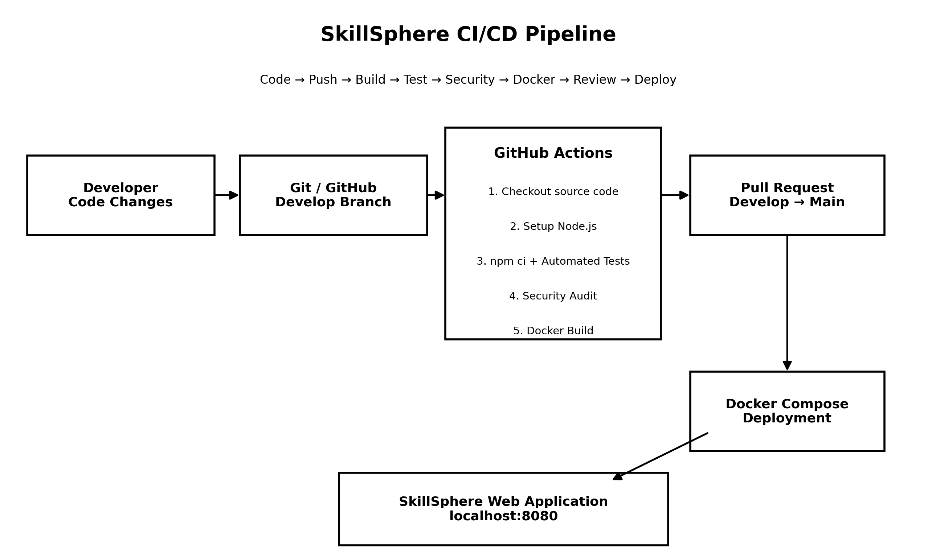
Figure: SkillSphere CI/CD pipeline architecture designed for the project

The pipeline is triggered by pushes and pull requests targeting main in the supplied workflow. The implementation shown in the evidence also demonstrates a successful workflow execution associated with the develop branch.

Pipeline Stage Breakdown
Each stage of the pipeline maps to a specific step in the GitHub Actions workflow, from the initial code checkout through to the final containerized deployment. The table below summarizes the purpose and mechanism of every stage shown in the architecture diagram.

Stage | Action | Tool / Command | Purpose
1. Checkout | Retrieves the latest source code onto the runner | actions/checkout@v4 | Ensures the workflow always runs against the current commit
2. Environment Setup | Installs the Node.js runtime and restores the npm cache | actions/setup-node@v4 (Node 24) | Provides a consistent, faster build environment across runs
3. Dependency Install | Installs backend dependencies from the lockfile | npm ci (backend working directory) | Guarantees reproducible installs that match package-lock.json
4. Security Audit | Scans installed dependencies for known vulnerabilities | npm audit --audit-level=high | Blocks the pipeline on high-severity security issues
5. Automated Testing | Runs the backend test suite | npm test (Node test runner) | Verifies functional correctness before code is merged
6. Docker Build | Builds the frontend and backend images | docker compose build | Confirms the application packages correctly for deployment
7. Pull Request Review | Integrates the develop branch into main | GitHub pull request | Adds a human review checkpoint before integration
8. Deployment | Starts the containerized services | docker compose up | Publishes the application at http://localhost:8080

4. Tools and Technologies
Stage | Tool | Purpose | Justification
Source control | Git + GitHub | Version history, branches and pull requests | Widely used distributed version-control workflow
CI/CD | GitHub Actions | Automated build/test/security workflow | Integrated with GitHub repository and easy to automate
Runtime | Node.js 24 | Backend execution | Matches the project backend
Testing | Node test runner / npm test | Automated backend validation | Simple and built into the Node.js platform
Security | npm audit | Dependency vulnerability check | Provides an automated dependency security gate
Containerization | Docker | Package application services | Provides consistent runtime environments
Orchestration | Docker Compose | Build and run frontend/backend together | Simple multi-service local deployment

Why GitHub Actions?
GitHub Actions was selected because the repository is already hosted on GitHub. A workflow file in .github/workflows can automatically execute commands whenever specified Git events occur. This reduces manual validation and gives visible pass/fail evidence.

Why Docker?
Docker separates the application runtime from the host machine. The frontend and backend can be built and started consistently, while Docker Compose provides a single command for multi-container deployment.

5. CI/CD Workflow Configuration
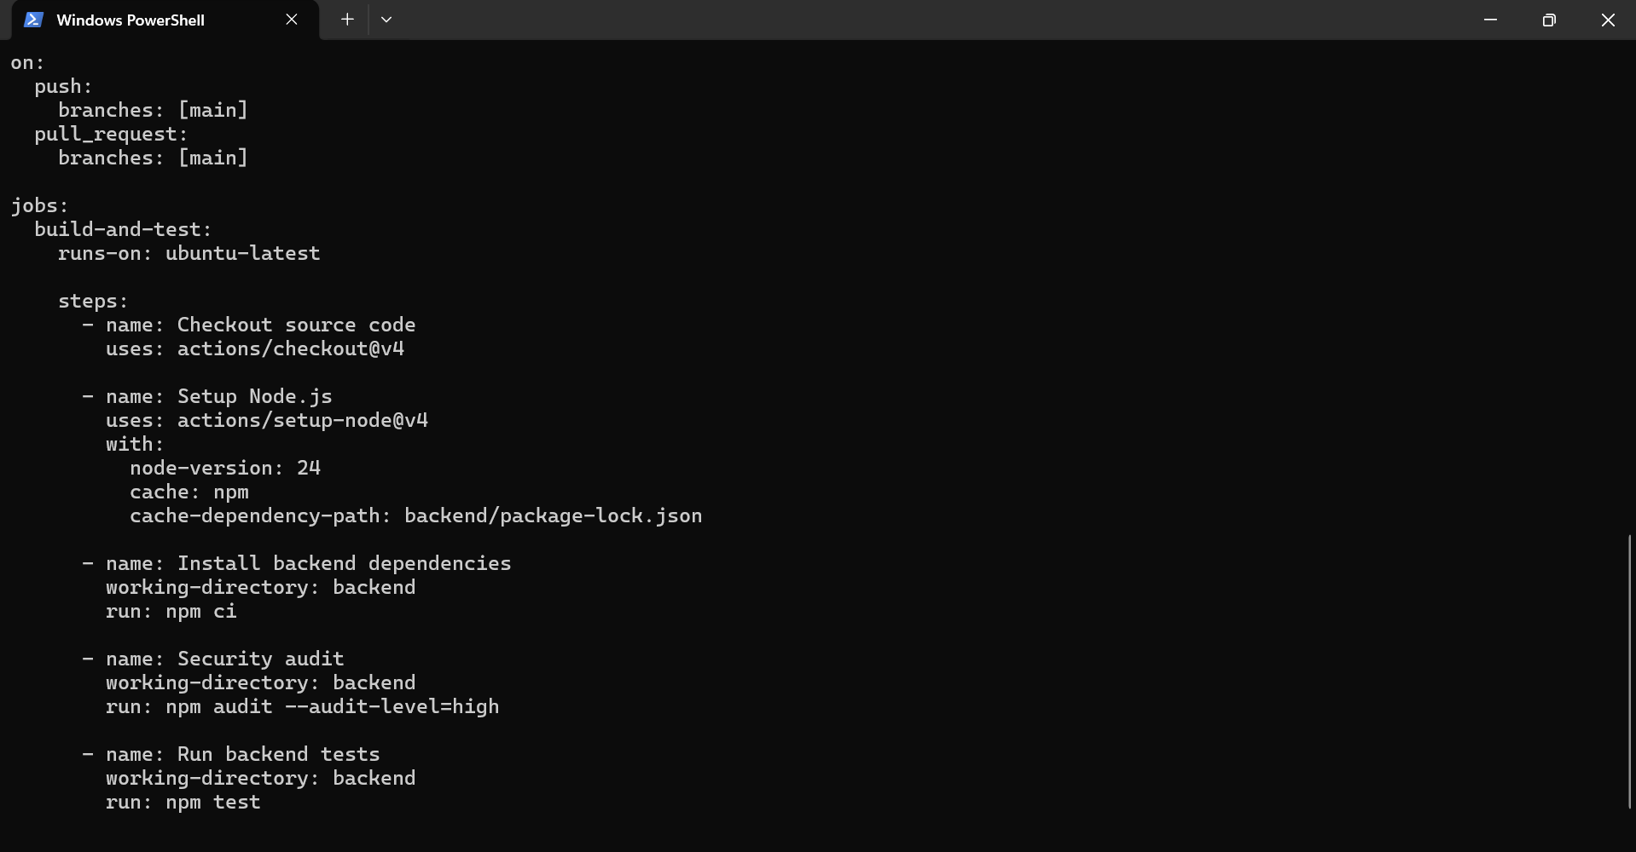
Figure 1: GitHub Actions workflow file showing checkout, Node.js setup, dependency installation, security audit, tests and Docker Compose build.
This workflow file defines the automated CI process for SkillSphere. The workflow first checks out the latest source code and prepares the Node.js environment. It then installs backend dependencies, performs a security audit, runs the automated tests, and finally validates that the Docker Compose images can be built. These automated steps reduce manual errors and provide repeatable validation whenever the workflow is triggered.

Workflow Trigger Configuration
The workflow is configured to run on two events: a push to the main branch and a pull request targeting main. This means every direct update to main and every proposed merge into main is automatically validated, while feature work on other branches such as develop can be pushed freely without triggering unnecessary runs until it is ready for review.

Job Environment and Caching
The build-and-test job runs on an ubuntu-latest GitHub-hosted runner. The Node.js setup step pins the runtime to Node 24 and enables npm caching, with the cache key derived from backend/package-lock.json. This means dependencies are only re-downloaded when the lockfile changes, which keeps repeat pipeline runs fast. All backend-specific steps set working-directory: backend so that npm commands execute against the correct package.json rather than the repository root.

6. Automated Testing Evidence
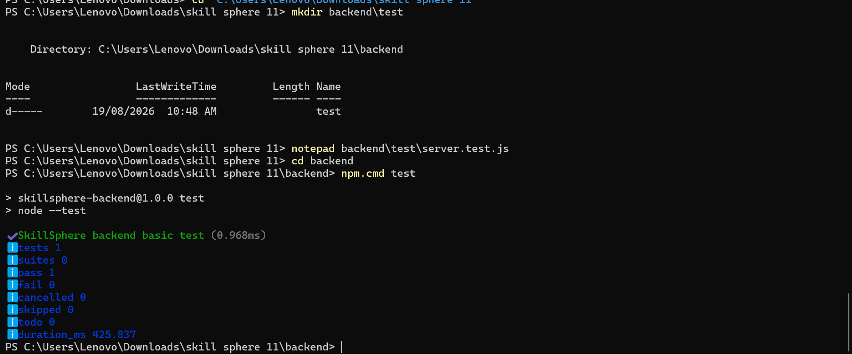
Figure 2: Successful npm test execution in the SkillSphere backend. The Node test runner completed with zero failures.
The test execution confirms that the backend test command is configured correctly and can be executed in the project environment. The result shown in the screenshot reports zero failed tests. This provides evidence that the automated testing stage of the CI pipeline completed successfully for the submitted code.

7. Successful GitHub Actions Run
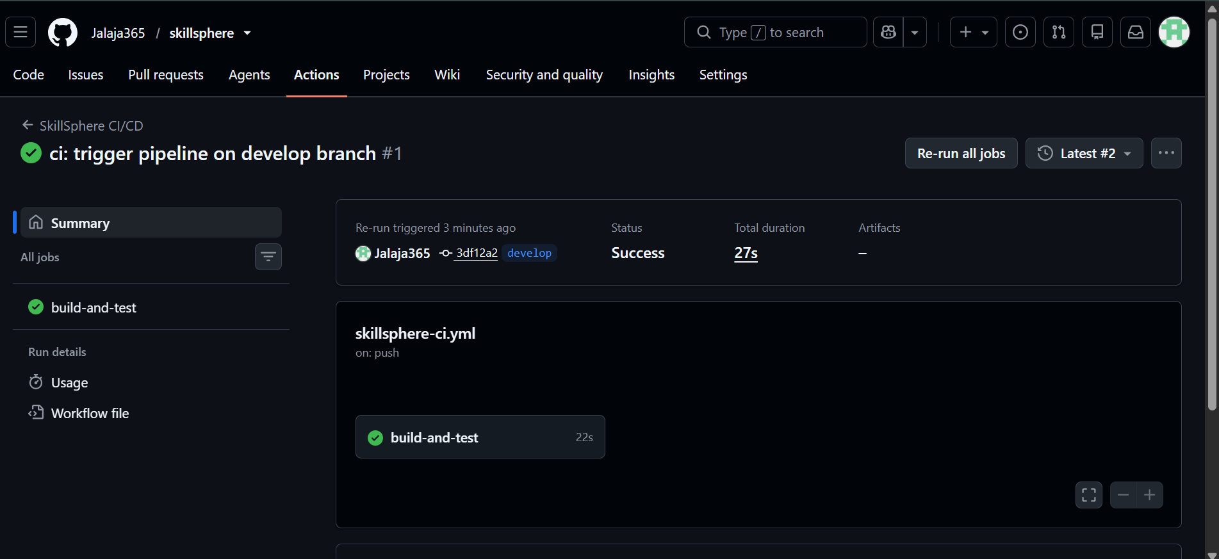
Figure 3: GitHub Actions CI/CD execution showing the build-and-test job with a successful status.
The green success status demonstrates that GitHub Actions completed the configured build-and-test job without failure. This is important because the pipeline gives immediate feedback after a repository change. A successful run indicates that the source checkout, Node.js setup, dependency installation, security audit, tests and Docker build validation passed in the workflow environment.
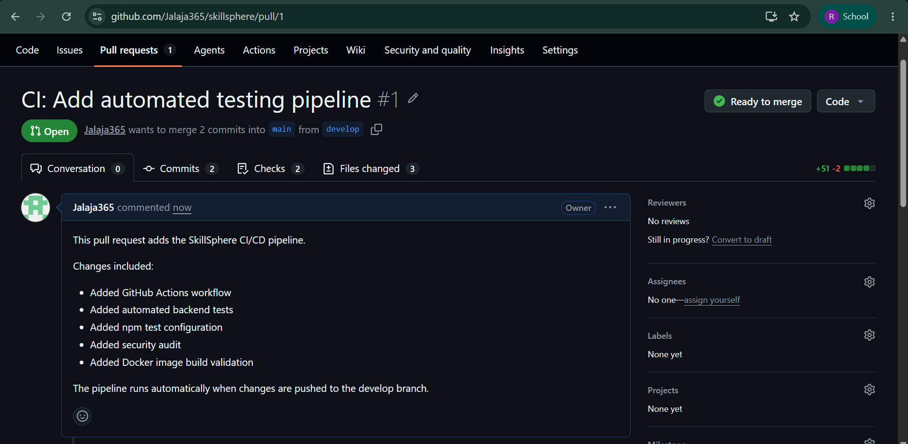
Figure 4: Pull request from develop to main for the automated testing pipeline. GitHub reports the pull request as ready to merge.
The pull request provides a controlled integration point between the development branch and the main branch. The screenshot shows that the changes can be merged automatically. This workflow supports code review, keeps the main branch more stable, and separates development work from the final integrated version.

9. Git Synchronization and Clean Working Tree
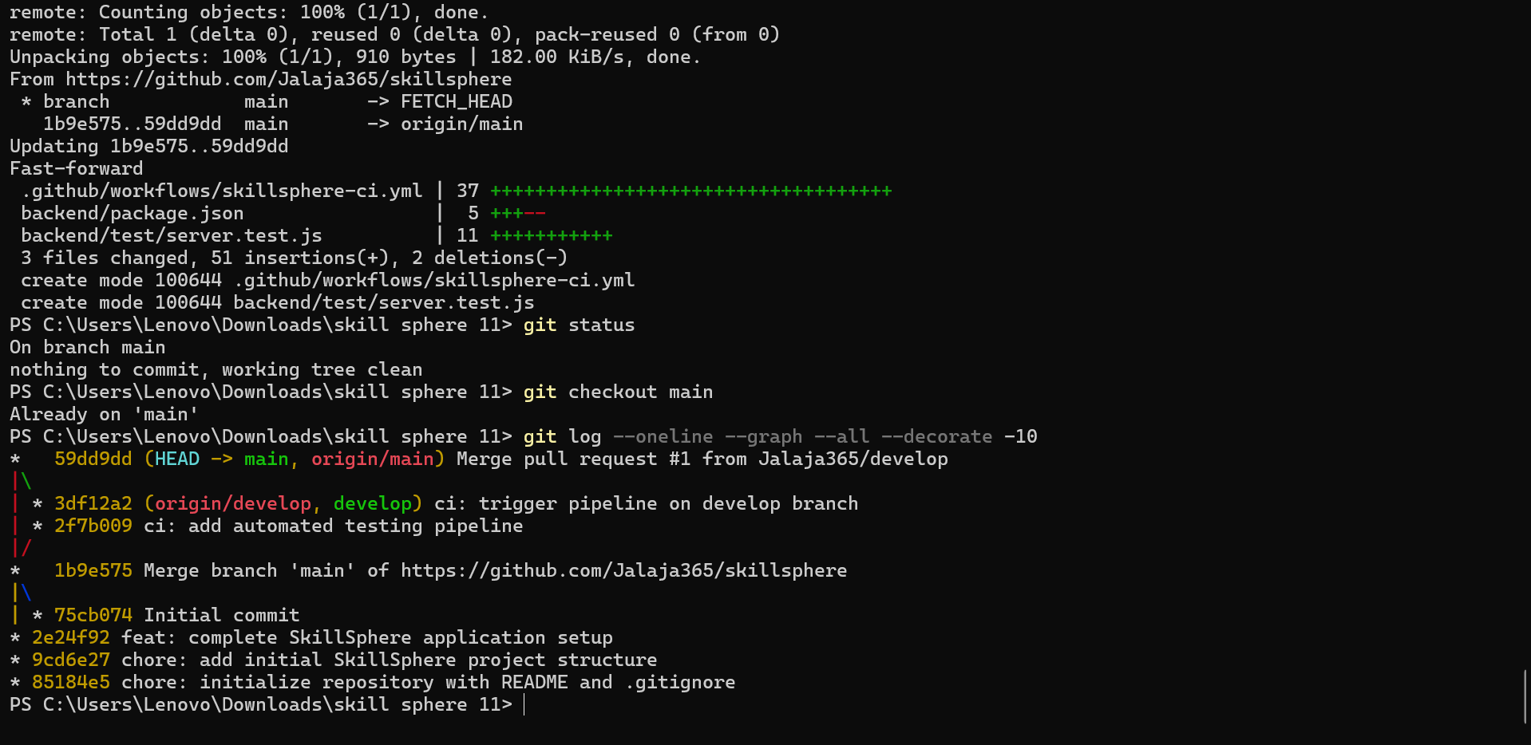
Figure 5: Git synchronization, branch status and clean working-tree evidence. The terminal also shows the project commit history.
A clean working tree is an important final verification step before submission. It confirms that the local project has no unexpected uncommitted changes. Keeping the local repository synchronized with the remote repository also helps ensure that the source code used for the report corresponds to the version stored in GitHub.

10. Commit History Analysis
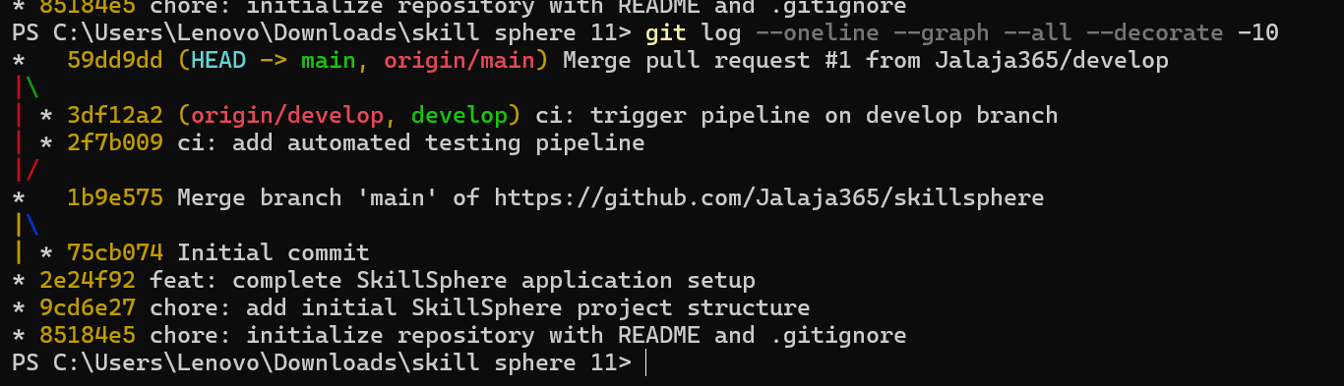
Figure 6: Git commit graph showing main/develop history and meaningful commit messages such as the CI pipeline change.
The commit history provides traceability for the development process. Separate branch history makes it possible to identify where the CI/CD work was introduced and how it was later integrated. Meaningful messages such as the CI pipeline commit make future maintenance easier because the purpose of a change can be understood without opening every modified file.

11. Application Validation
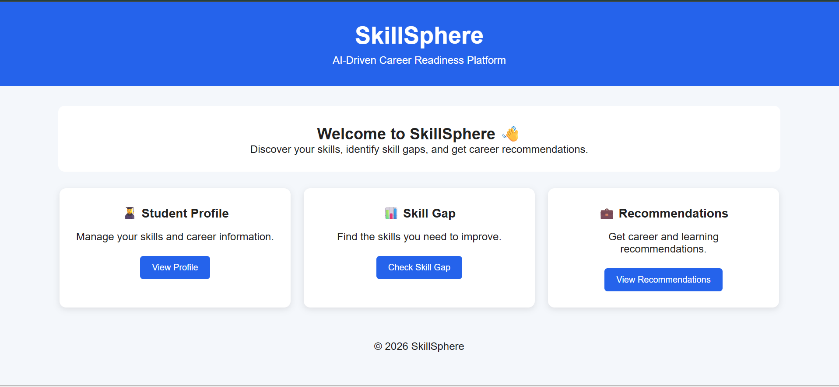
Figure 7: Working SkillSphere web application interface, demonstrating successful frontend deployment.
The working application is the final functional validation of the deployment process. The visible SkillSphere interface confirms that the frontend can be reached through the configured local port. This complements the automated CI checks by showing the result from an end-user perspective.

12. Deployment and Validation Procedure
- Commit or push source changes to the configured Git branch.
- GitHub Actions checks out the repository and installs Node.js.
- The backend dependencies are installed using npm ci.
- npm audit checks for high-severity dependency vulnerabilities.
- npm test executes the automated backend tests.
- Docker Compose builds the application images.
- Validated changes are submitted through a pull request from develop to main.
- After integration, Docker Compose can be used to start the frontend and backend services.
- The frontend is validated through the SkillSphere interface at http://localhost:8080.

Evidence-Based Validation
- The supplied screenshots show a successful GitHub Actions run.
- The supplied terminal screenshot shows npm test completing with zero failures.
- The supplied pull request screenshot shows develop → main and a ready-to-merge state.
- The supplied application screenshot shows the SkillSphere interface running successfully.

Note on Docker Evidence
The supplied screenshot set contains the CI/CD workflow, test, Git, pull-request and application evidence. A separate docker compose up -d / docker compose ps screenshot was not included in the uploaded document, so this report does not claim that such a screenshot was supplied.

13. Security, Quality and Rollback Strategy

Security Checks
- Run npm audit with --audit-level=high to detect high-severity dependency issues.
- Avoid committing secrets, passwords or tokens to the repository.
- Keep dependencies and base images updated.
- Use GitHub repository permissions and branch protection where available.

Quality Checks
- Automated tests run before integration.
- Docker image build acts as an additional packaging validation.
- Pull requests provide a review and integration checkpoint.
- Meaningful commit messages improve traceability.

Rollback Mechanism
If a change causes a production or deployment problem, Git makes previous commits available for comparison and recovery. A safer deployment process can also retain the previous Docker image/tag so the application can be returned to the last known-good version.

Recommended Future Improvements
- Add more backend unit and integration tests so the test stage reports meaningful test coverage.
- Add frontend automated tests.
- Add a dedicated staging environment before production.
- Publish versioned Docker images to a container registry.
- Add code-quality analysis such as linting and static analysis.
- Add notifications for failed CI/CD runs.
- Use protected main branch rules and required pull-request checks.

14. Challenges and Improvements

Challenges Encountered
- PowerShell syntax was initially confused with GitHub Actions YAML syntax; for example, `run: npm test` belongs inside the workflow file, not as a PowerShell command.
- The project initially had no npm test script; the backend package configuration was updated to use the Node test runner.
- The Git repository required synchronization between local and remote histories before pushing.
- Docker Desktop/API availability caused connection errors during earlier deployment attempts; successful Docker operation requires the Docker engine to be running.

How the Process Was Improved
- The CI workflow was stored in `.github/workflows/skillsphere-ci.yml`.
- Automated backend test files were added under `backend/test`.
- The `develop` branch was used for CI/CD changes and a pull request was created toward `main`.
- GitHub Actions provided visible execution evidence.
- Docker Compose remained the deployment mechanism for the multi-service application.

Overall Evaluation
The SkillSphere project demonstrates the core CI/CD lifecycle: source control, automated validation, security checking, Docker build validation, pull-request integration and application deployment. The current implementation is suitable as a foundation for a student CI/CD exercise, while additional automated tests, staging deployment, quality gates and production safeguards would strengthen it for a real-world environment.

15. Conclusion
The SkillSphere CI/CD design combines GitHub version control, GitHub Actions, Node.js testing, npm security auditing and Docker-based deployment. The workflow reduces manual effort and provides repeatable evidence that changes can be checked before integration.
The submitted evidence demonstrates a successful CI/CD workflow, successful automated test execution, a pull request from develop to main, Git history and a working SkillSphere application. Together these elements satisfy the main objectives of the CI/CD pipeline design exercise.

Repository
https://github.com/Jalaja365/skillsphere

Suggested Report Submission Checklist
- Technical report completed.
- Git repository link included.
- CI/CD workflow configuration included.
- Automated test evidence included.
- Git commit and pull-request evidence included.
- Application validation screenshot included.
- Docker deployment screenshots can be added if required by the faculty.

